26. Insert watermarking to the image using OpenCV.

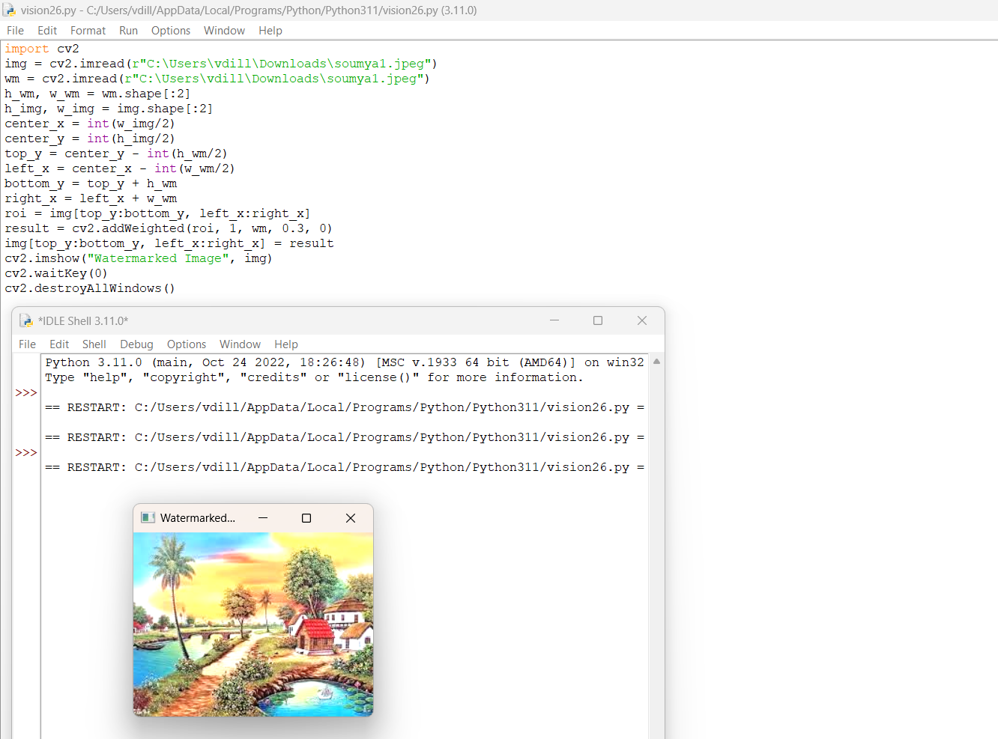

27. Do Cropping, Copying, and pasting image inside another image using OpenCV.

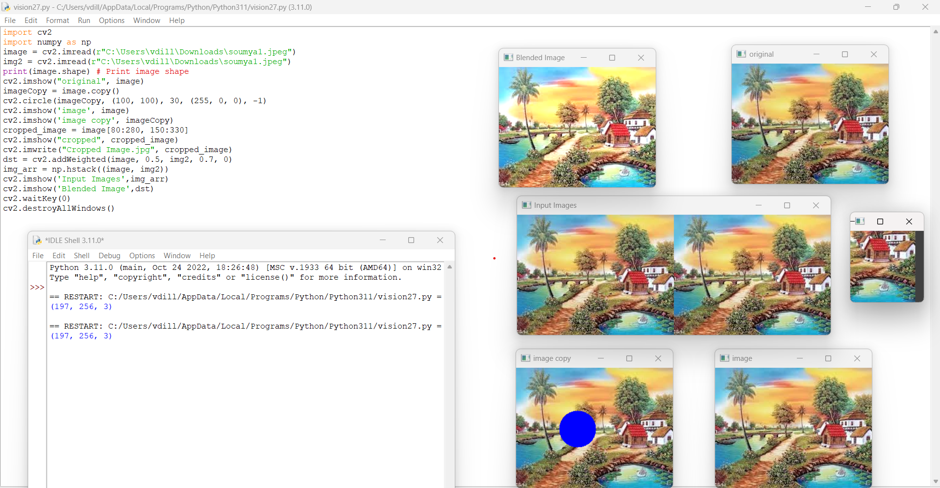

28. Find the boundary of the image using the Convolution kernel for the given image.

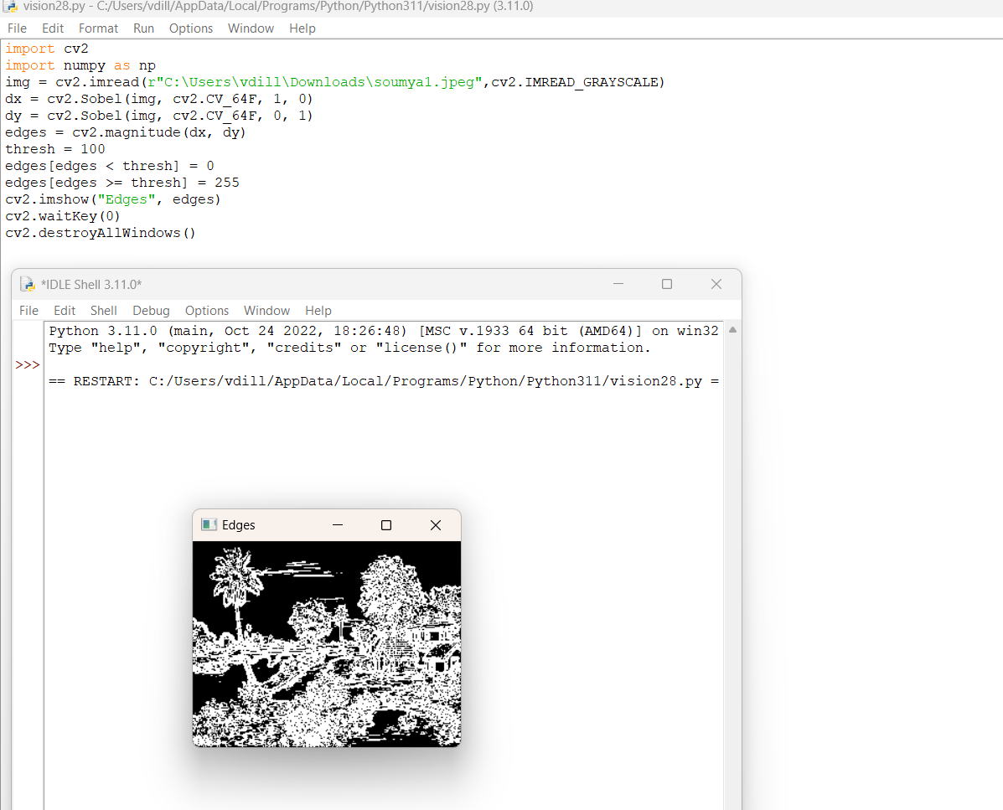

29. Morphological operations based on OpenCV using Erosion technique.

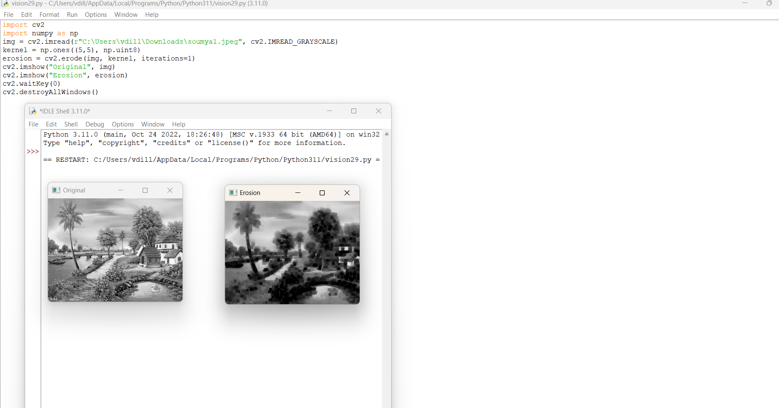

30. Morphological operations based on OpenCV using Dilation technique.

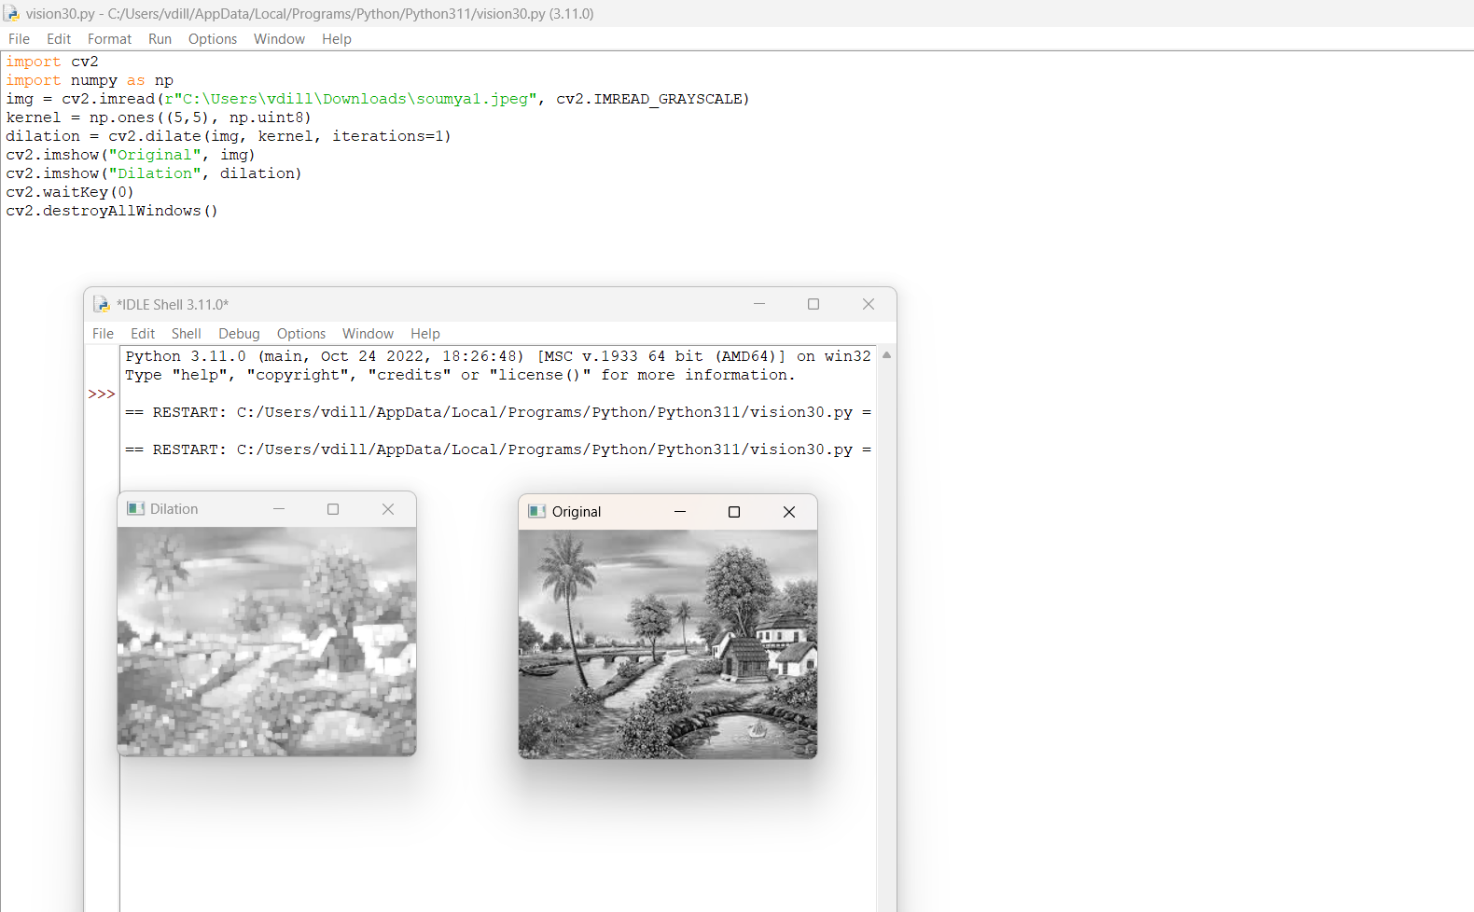

31. Morphological operations based on OpenCV using Opening technique.

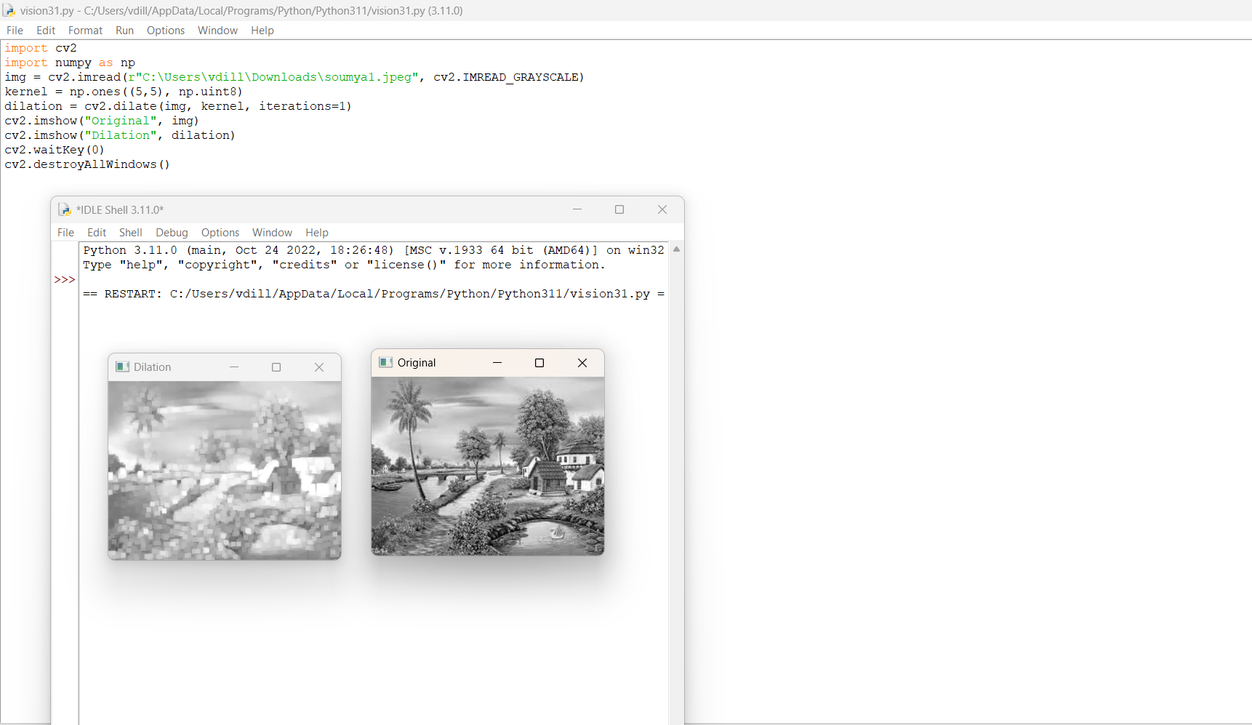

32. Morphological operations based on OpenCV using the Closing technique.

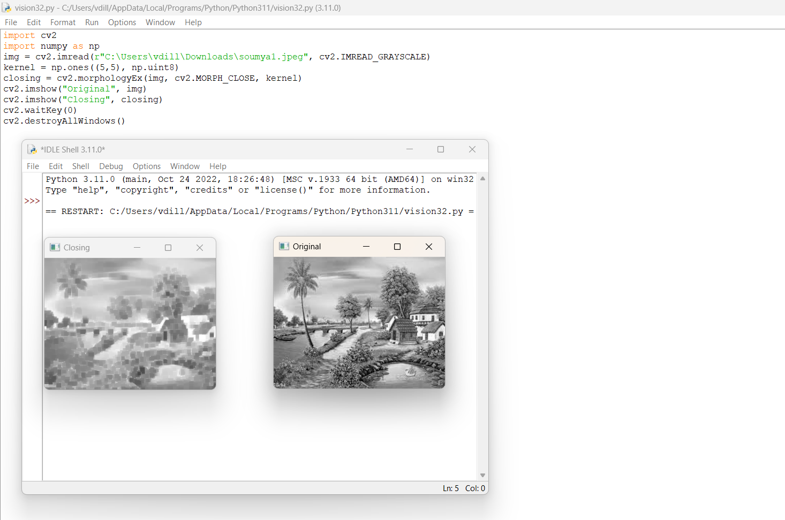

33. Morphological operations based on OpenCV using the Morphological Gradient technique.

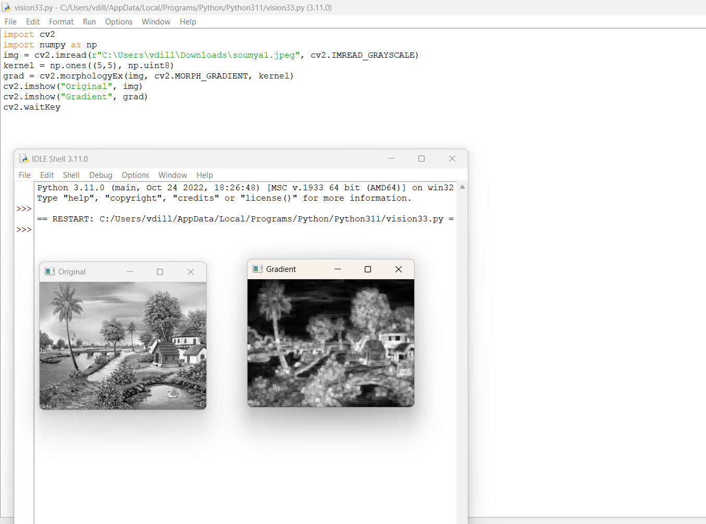

34. Morphological operations based on OpenCV using the Top hat technique.

